**IT24610817**

**Gunasena B.R.S.**

**Lab Sheet 08**

01)

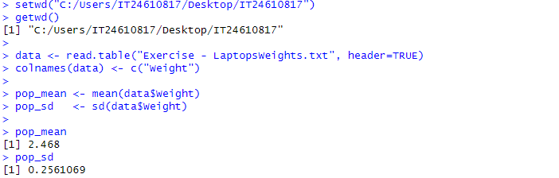

02)

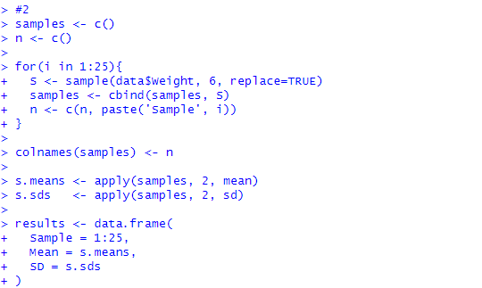

03)

